Personal Information:
Name _____________________________________________ Phone (Day/Night) ______________________________
Address __________________________________________________________________________________________
City/State/Zip _____________________________________________________________________________________
Email _________________________________________ Occupation _________________________________________
Emergency Contact ________________________________ Relationship _____________ Phone ___________________
The following information will be used to help plan safe and effective massage sessions.
Please answer questions to the best of your knowledge.
Date of Initial Visit : ________________________________________________________________________________
1. Have you had a professional massage before? YES NO
If Yes, how often do you receive massage therapy? _________________________________________________
2. Do yoy have any difficulty lying on your front, back, or side? YES NO
If yes, please explain _________________________________________________________________________
3.Do you have any allergies to oils, lotions, or ointments? YES NO
If yes, please explain __________________________________________________________________________
4. Do you have sensitive skin? YES NO
5. Do you perform any repetitive movements in your work, sports, or hobbies? YES NO
If yes, please explain _________________________________________________________________________
5. Is there a particular area of the body where you are experiencing tension, stiffness, pain, or discomfort? YES NO
If yes, please identify __________________________________________________________________________
6. Do you have any particular goal in mind for this massage session? YES NO
If yes, please explain __________________________________________________________________________
Circle any specific areas you would like the massage therapist to concentrate on during the session.
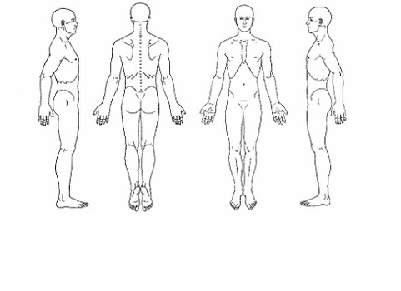

Medical History
In order to plan a massage session that is safe and effective I need some general information about your medical history.
7. Are you currently under medical supervision? Yes NO
If yes, please explain ___________________________________________________________________
8. Do you have any allergies? YES NO If yes, please list ____________________________________________
8. Do you see a Chiropractor? YES NO If yes, how often? _________________________________________
9. Are you currently taking any medications? YES NO
If yes, please list ______________________________________________________________________
____________________________________________________________________________________
10. Please check any conditions listen below that applies to you:
[ ] Contagious condition [ ] Phlebitis
[ ] Open sores/wounds [ ] Deep vein thrombosis/bloodclots
[ ] Recent Surgery [ ] Joint Disorder (Arthritis, Tendonitis, est. )
[ ] Recent Accident or Injury [ ] Osteoporosis
[ ] Recent fracture/sprain [ ] Epilepsy/Seizures
[ ] Artificial Joints [ ] Headaches/Migraine
What joint(s)? __________________ __ How Often? ____________________________________
[ ] Easy Bruising [ ] Cancer
[ ] Decreased Sensations [ ] Diabetes
[ ] Heart condition [ ] Back/ Neck problems
[ ] High or low blood pressure [ ] Fibromyalgia
[ ] Circulatory disorder [ ] TMJ
[ ] Varicose Veins [ ] Carpal Tunnel Syndrome
[ ] Atherosclerosis [ ] Pregnancy If Yes, how many weeks? ________________
15. Is there anything else about your health history that you think would be useful for you massage practitioner to know to plan a safe and effective massage session for you ? _____________________________________________________
_________________________________________________________________________________________________
_________________________________________________________________________________________________
Draping will be used during the session – only the areas being works on will be uncovered. Clients under the age of 18 must be accompanied by a parent or legal guardian during their session. Informed consent must be provided by the parent or legal guardian for any client under the age of 18 and the parent will be responsible for all charges.

Client Consents
I, __________________________ [print name] understand that the massage I receive is provided for the basic purpose of relaxation and relief of muscular tension. If I experience any pain or discomfort during this session, I will immediately inform the therapist so that the pressure and/or stroke may be adjusted to my level of comfort. I further understand that the massage should not be construed as a substitute for medical examination, diagnosis, or treatment and that I should see a physician, chiropractor, or other qualified medical specialist for any mental of physical ailments I’m aware of. I understand massage therapists are not qualified to perform spinal or skeletal adjustments, diagnose, prescribe, or treat any physical or mental illness, and that nothing said in the course of the session given should be construed as such. Because massage should not be performed under certain medical conditions, I affirm that I have stated all my known medical conditions, and answered all questions honestly. I agree to keep the therapist updated as to any changes in my medical profile and understand that there shall be no liability on the therapists part should I fail to do so.
Client Late Notice and Cancelation Policies
I also understand that in order for the therapist to be able to give outstanding customer service there is a requirement of a minimum 24 hour cancelation notice. This allows the therapist time to fill your spot with another client when a cancelation does occur. Any cancellations outside of emergencies and illness without the minimum 24 hour notice will be charged for 50% of the service and all no shows will be charged for the entire missed service. These charges must be taken care of prior to scheduling any future appointments with the therapist.
Sometimes being late is outside of our control. The therapist will always do their best to accommodate any late arrivals. But depending upon how late you arrive, it may require the therapist to shorten your session to accommodate for thoughs appointments that follow yours. Regardless of the length of the treatment actually given, you will be responsible for the “full” scheduled session. Out of respect and consideration to your therapist and other clients, please plan accordingly and be on time.

Clients printed name: ________________________________________________________
Client Signature: ____________________________________________________________ Date: __________________
Therapists Signature: ________________________________________________________ Date: __________________

